ERC In-House Basketball League Rules

Contents
League Wide Rules 2
5-6 Boys/Girls Clinic 3
7-8 Boys/Girls 4
9-10 Boys/Girls 5
11-12 Boys/Girls 6
13-15 Boys/Girls 7
Playtime Requirements 8

League Wide Rules

- Coaches, Players, and Parents are subject to the ERC Youth Basketball Code of Conduct at all times during the season
- Only the head coach is allowed to stand. Assistant coaches standing will result in a warning followed by a technical foul for a second violation.
- Each team receives 2 full and 2 30-second timeouts for the entire game. Timeouts do not carryover into overtime (if applicable).
- NO JEWELRY is allowed to be worn. Shirts are to be tucked into shorts around the waist.
- ALL PLAYERS MUST WEAR SHORTS. Leggings are allowed under the shorts.
- Players foul out of game upon committing their 5th individual foul
- For age divisions 7-8 and 9-10, a parent volunteer is to be provided by each team to serve as the game timekeeper or bookkeeper.
- For age divisions 11-12 and 13-15, a timekeeper/bookkeeper will be provided for all games.
- Overtime Rules:
  - Regular Season: If agreed there is time, 2-minute running clock. 1 full timeout for each team (no regulation timeouts carryover). Repeat if time allows. No additional timeouts.
  - Playoffs: 2-minute stop clock (on whistle), 1 full timeout for each team (no regulation timeouts carryover). Repeat if necessary. 1 full timeout for each team during a given overtime period (no carryover from previous overtime period).
- All jersey numbers are legal
- In order to start an officiated game by referees, a minimum of 5 players are required. Referees will not officiate a game with a team with less than 5 players and that team will forfeit. A forfeit will be considered 10 minutes after the scheduled game start.
- A game must end and team is considered forfeited if a team gets to 3 players (i.e. 2 foul out).
- Eligible Players must be on the current approved roster. This excludes Teams from having another/alternate Emmorton player not on that team participating in the game.

5-6 Boys/Girls Clinic

Specification | Rule
Basketball  Size (dia) | 27.5” (size 5)
Rim Height | 8 ft

Non-officiated scrimmages between the teams sharing the court will be held during sessions 6-10. During these sessions, practice will be limited to 30 minutes, followed by a 24-minute scrimmage (Two 12-min halves timed and run by the coaches). These scrimmages are always a great way to exercise the fundamentals the kids are learning during practice. Applying the skills to a game setting within the rules will always be a challenge. Therefore, these scrimmages are viewed more as an interactive learning simulation than a traditional basketball game.
Scrimmage Rules/Logistics:
- Scrimmages will use the entire court and play 5-5. If one team is short on players, the coaches can decide to play 4-4.
- Scores are not kept.
- Each head coach should be out on the court helping their players as they will surely need real-time coaching to stay organized. ONLY 1 COACH ON THE COURT PER TEAM TO LIMIT THE NUMBER OF PEOPLE/VOICES ON THE COURT.
- Assistant coaches are to serve as the bench coach during scrimmages to keep the kids seated on the bench and manage substitutions so you can focus on the in-game coaching.
- Players are to receive equal playing time based on the number of players available for the scrimmage.
- Traveling and double dribbling is not a turnover. That being said, if a player travels or double dribbles, continuously reinforce the skills they’re learning and encourage them to use proper fundamentals.
- Out of bounds is to be called at the coaches’ discretion (i.e. if a player dribbles off their foot out of bounds bringing the ball up the court, they can reset and play continue). However, continuously remind players of the court boundaries.
- At the start of the scrimmage, after a made basket, or dead ball, have the player in-bounds the ball from out of bounds to a teammate.
- There is no pressing. The players are encouraged to bring the ball up the floor to start their half-court offense. After the team on defense obtains possession, the other team is to hustle down court and set up on defense.
- To encourage offense with the teams, defensive players are to stay within the 3-point arc.
- Fouls are to be called by the coaches at their discretion. If a foul occurs, stop play and reset the play at the top of the key (No need to inbound the ball from out of bounds).

7-8 Boys/Girls

Specification | Rule
Basketball  Size (dia) | 28.5” (size 6)
Rim Height | 9 ft
Time/Clock  Stoppage | - Four 8-min quarters  - Clock stops last 2 minutes each half and until foul shooter gets first ball on foul shots
Key  Violation | 5 seconds
Pressing | - Offensive players must go back on defense when a defensive player gets a rebound and gets control. No full court press unless fast break – fast break is defendable. If offensive fast break halts – defense must retreat to inside the arc.  - Half Court press is allowed the last two minutes of each half  - No press if team winning by 10+ points. Press can resume if lead goes below 10 points.
Offense | - Violation if offense doesn’t cross half court within 10 seconds  - Backcourt violation in effect  - 3-pt line counted as 2 points  - No Stalling. A warning will be given to the offensive team at the discretion of the refs. If continued, the ball will be turned over to the defensive team.
Defense | - Zone defense only  - Defensive players must stay inside the arc until the offense penetrates the arc at each possession. No reaching over the arc by defensive players. Once the offensive player enters the arc area, the defense is allowed outside of the arc area (even if the offensive player goes back outside the arc). If the ball goes out of bounds, it resets, and the defense must return to inside the arc until re-entered by the offense.
Fouls | - Players foul out on 5th individual foul  - No 1-shot single bonus (7 team fouls in a half) during regular season play. Only 2-shot double bonus (10 team fouls in a half).  - Single bonus in effect during end of season tournament play.
Subbing | - Gameplay halted and clock stopped as close to 4-minute intervals as possible for substitutions.  - Refer to “Playtime Requirements” section for substitution guidelines.

9-10 Boys/Girls

Specification | Rule
Basketball  Size (dia) | 28.5” (size 6)
Rim Height | 10 ft
Time/Clock  Stoppage | - Four 8-min quarters  - Clock stops last 2 minutes each half and until foul shooter gets first ball on foul shots
Key  Violation | 5 seconds
Pressing | - Half court press is allowed the first 3 quarters  - Offensive players must retreat to half court when defensive player gains possession of the ball  - Offensive players can re-defend if defensive team tries to fast break  - Full court press is allowed in the 4th quarter  - No full court press if team winning by 10+ points (leading team must retreat to half court). Full court press can resume if lead goes below 10 points.
Offense | - Violation if offense doesn’t cross half court within 10 seconds  - Backcourt violation in effect  - 3-pt shots count as 3 points
Defense | - Zone defense and man-to-man defense allowed
Fouls | - Players foul out on 5th individual foul  - No 1-shot single bonus (7 team fouls in a half) during regular season play. Only 2-shot double bonus (10 team fouls in a half).  - Single bonus in effect during end of season tournament play.
Subbing | - Gameplay halted and clock stopped as close to 4-minute intervals as possible for substitutions.  - Refer to “Playtime Requirements” section for substitution guidelines.

11-12 Boys/Girls

Specification | Rule
Basketball  Size (dia) | - Girls: 28.5” (size 6)  - Boys: 29.5” (size 7)
Rim Height | 10 ft
Time/Clock  Stoppage | - Two 20-min halves  - Running clock the first 18 minutes of each half. Clock stops on the whistle the last 2 minutes of each half.  - Clock runs the final 2 minutes of the game if team up by 15+ points. If lead reduces below 15 points, clock will stop on the whistle.
Key  Violation | 3 seconds
Pressing | - Full court press is allowed the entire game  - No full court press if team winning by 15+ points (leading team must retreat to half court). Full court press can resume if lead goes below 15 points.
Offense | - Violation if offense doesn’t cross half court within 10 seconds  - Backcourt violation in effect  - 3-pt shots count as 3 points
Defense | - Zone defense and man-to-man defense allowed
Fouls | - Players foul out on 5th individual foul  - 1-shot single bonus (7 team fouls in a half) and 2-shot double bonus (10 team fouls in a half) during regular season and end of season tournament play.
Subbing | - Gameplay does not stop for substitutions as with the younger age groups; however, coaches are expected to clear their benches every 5 minutes if they have not been subbing regularly (i.e. no player should sit for more than 5 minutes at time) and are required to abide by all substitution rules.  - Refer to “Playtime Requirements” section for substitution guidelines.

13-15 Boys/Girls

Specification | Rule
Basketball  Size (dia) | - Girls: 28.5” (size 6)  - Boys: 29.5” (size 7)
Rim Height | 10 ft
Time/Clock  Stoppage | - Two 20-min halves  - Running clock the first 18 minutes of each half. Clock stops on the whistle the last 2 minutes of each half.  - Clock runs the final 2 minutes of the game if team up by 15+ points. If lead reduces below 15 points, clock will stop on the whistle.
Key  Violation | 3 seconds
Pressing | - Full court press is allowed the entire game  - No full court press if team winning by 15+ points (leading team must retreat to half court). Full court press can resume if lead goes below 15 points.
Offense | - Violation if offense doesn’t cross half court within 10 seconds  - Backcourt violation in effect  - 3-pt shots count as 3 points
Defense | - Zone defense and man-to-man defense allowed
Fouls | - Players foul out on 5th individual foul  - 1-shot single bonus (7 team fouls in a half) and 2-shot double bonus (10 team fouls in a half) during regular season and end of season tournament play.
Subbing | - Gameplay does not stop for substitutions as with the younger age groups; however, coaches are expected to clear their benches every 5 minutes if they have not been subbing regularly (i.e. no player should sit for more than 5 minutes at time) and are required to abide by all substitution rules.  - Refer to “Playtime Requirements” section for substitution guidelines.

Playtime Requirements

For Age Divisions 7-8 and 9-10:
# of Players | Required Playing Time
10 | All players play 4 segments (half the game)
9 | 4 players play 5 segments, 5 players play 4 segments
8 | All players play 5 segments
7 | 5 players play 6 segments, 2 players play 5 segments
6 | 4 players play 7 segments, 2 players play 6 segments
5 | All players play the entire game

- Coaches are to have a copy of their substitution sheet available for the opposing coach at the start of the game and/or upon request if a substitution concern arises during the game.
  - Note: Referees are not responsible for monitoring playing time of players or challenges of players’ playing time.
- Game play halted as close to 4-minute intervals as possible for substitutions.
- Failure to provide substitution sheet or following substitution rules may result in delayed start and possible forfeit.

Sample Substitution Chart:
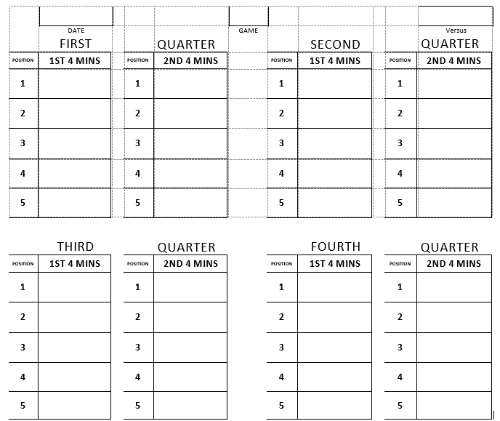
For Age Divisions 11-12 and 13-15:
# of Players | Required Playing Time*
10 | All players play 20 minutes (half the game)
9 | 4 players play 25 minutes, 5 players play 20 minutes
8 | All players play 25 minutes
7 | 5 players play 30 minutes, 2 players play 25 minutes
6 | 4 players play 35 minutes, 2 players play 30 minutes
5 | All players play the entire game
*Approximate playing time given that the clock does not stop for substitutions
- Coaches are to have a copy of their substitution sheet available for the opposing coach at the start of the game and/or upon request if a substitution concern arises during the game.
  - Note: Referees are not responsible for monitoring playing time of players or challenges of players’ playing time.
- Failure to following substitution rules may result in forfeit.

Sample Substitution Chart:
